AUTOMATIC DUSK TO DAWN (EVENING ON TO MORNING OFF)
ABSTRACT
The main objective of this project is to design a system where light will remain on only from dusk to dawn.
As per–unit electricity cost is very high these days, so it is advisable to judiciously use electricity. Places like colleges, housing complexes, highways, industries and parks spread across large area where more light is required during night. This system provides a solution for these places, as dusk to dawn system the lights will be automatically on at dusk and switch off at dawn. Thus, saving energy and money also human intervention is also eliminated.
This system is based on an LDR, it senses the change in intensity of light and its output changes accordingly. The output of the LDR is fed to a 555 timer in astable mode, which switches on light during dusk and switches off at dawn. 555 timer controls the load through a TRIAC.
BLOCK DIAGRAM:
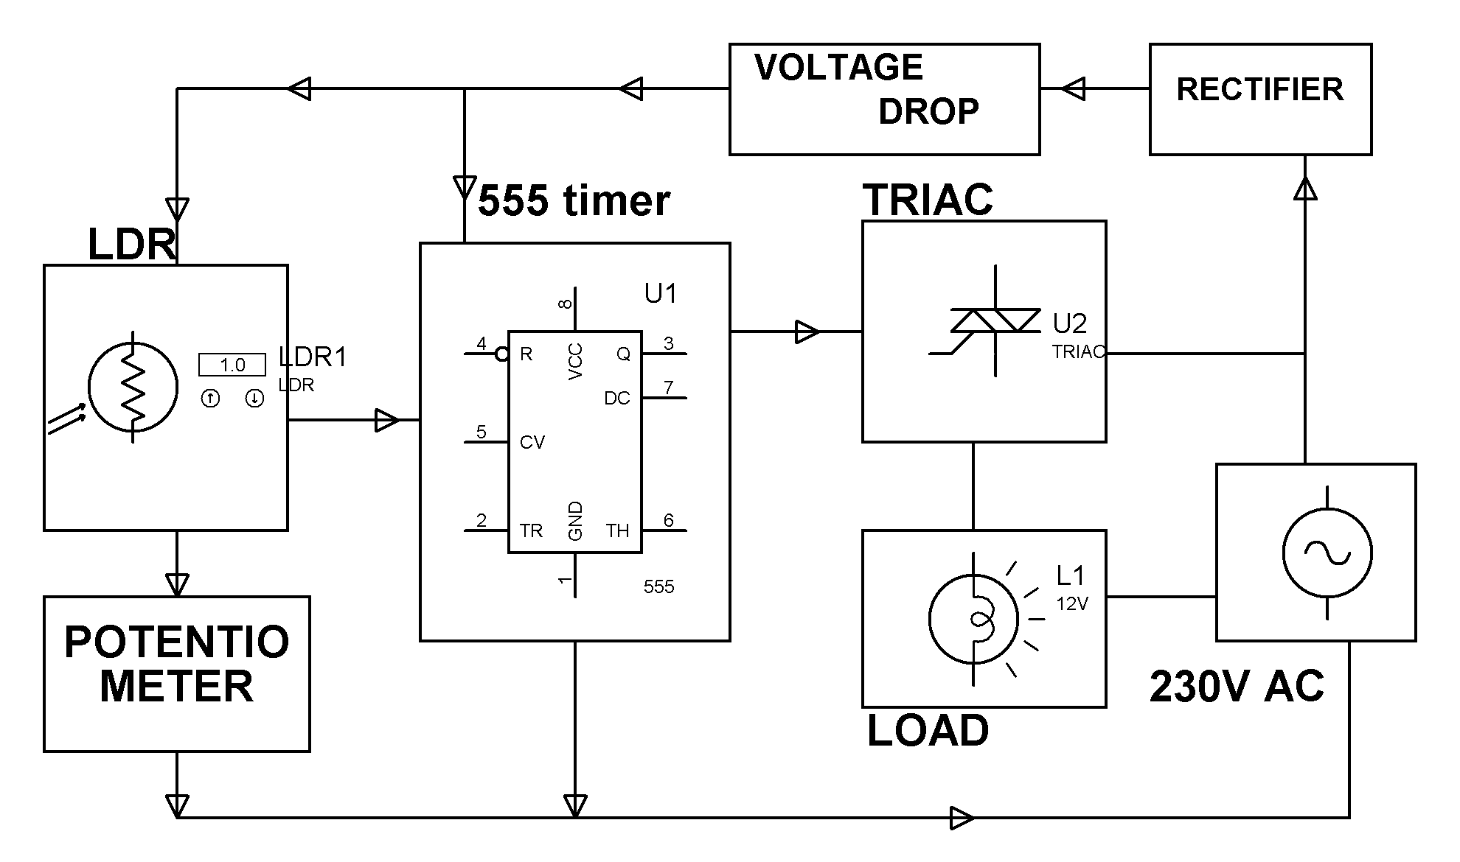
HARDWARE REQUIREMENTS:
555Timer, LDR, Potentiometer, Bulb, LED, TRIAC, diodes, capacitors, resistors.

